Practice Sheet for Functions

**Text and Date-Time Functions**

Create the below worksheet and implement all the questions:

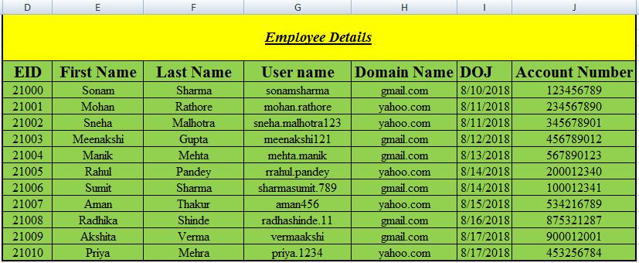

1. The title written in the table Employee Details must be bold, italic and underline. It must be times new roman having size 14.

2. Size of the column names must be 16, times new roman and centered.

3. All the data of the table must be times new roman, 12 and centered.

4. There must be outer thick border.

5. Inner border must also be there.

6. Add a new column to the worksheet New First Name and convert all first names into lower case.

7. Add a new column City to the worksheet and add cities for all the employees in small letter.

8. Then add a new column to the worksheet New City and convert all the cities written into small letter to capital letter.

9. Concatenate the data of Username and Domain Name column to form one new column Email id.

10. Find left 4 digits of account number for first 3 employees.

11. Find right 6 digits of account number of next 4 employees.

12. Find 5 digits of the account number starting from 4th digit of the account number.

13. Find the number of elements present in the email id of the employees.

14. Add a new column in the worksheet Year, and find the year of joining for all employees.

15. Add a new column in the worksheet Date, and find the date of joining for all employees.

16. Find the gap between dates of joining of every two employees.

17. Find the weekday according to the DOJ for every employee.